### DEVELOPING AN ERP FOR OUTCOME BASED EDUCATION

PROJECT SYNOPSIS

OF MAJOR PROJECT

BACHELOR OF TECHNOLOGY

## Information Technology

### SUBMITTED BY

### Saurav Kumar (1805449) Gurlivleen Singh Kainth (1805511)



GURU NANAK DEV ENGINEERING COLLEGE, LUDHIANA-141006

Contents

1. Introduction 1
2. Objectives 2
3. Feasibility Study 3
4. Methodology/Planning of work 4
5. Facilities required for proposed work 6

# Introduction

Graduates of engineering program in India are required to attain the Course Outcome (CO), Program Out- come(PO) identi ed by the NBA and Program Speci c Outcome (PSOs) identi ed the University or the Department o ering the Program. Basically this project is going to calculate the Attainment level of CO/PO and PSO . CO are attained through particular course and PO and PSO are to attain through projects, co- curricular and extra-curricular activities in which performance of the students is evaluated. For developing this project needs to have knowledge about Outcome Based Education, Course Attainment, Program Outcome and Program Speci c Outcome. Object Based Education(OBE) is student centered instruction that focuses on measuring student performance i.e. outcomes.

Outcomes include knowledge skills and attitudes. Outcome based accreditation focus remains on evalua- tion of outcomes of the program, though Input and Output parameters are also important. Course Outcomes (COs) are what the student should be able to do at the end of a course. E ective ability, including attributes, skills and knowledge to successfully carry out the identi ed activity. Most important aspect of a CO is that it should be observable and measurable CO statement starts with an Action Verb from one of the cognitive levels. Use the acronyms R-Remember, U-Understand, Ap- Apply, An-Analyze, E-Evaluate and C-Create. A CO may have two action verbs. Then it is tagged by two cognitive levels. There are Same target is identi ed for all the COs of a course. (Simplest one) Targets are set for each CO of a course separately (Bit Complex). For example, Target can be the class average marks > 60 marks for Whole Mechanical Engineering or they can 60% for Subject `A' 55 % for Subject `B' and so on.

Attainment of course outcome calculate in two methods one is Direct and other is Indirect. Program Outcome and program speci c outcome can be addressed through core courses, minor and major projects, internships and seminars/presentation. POs are attained through program speci c Core Courses. There are 12 Program Outcome de ne by NBA. these are grab by student to get good attainment. Necessary to determine the level (mapping strength) at which a particular PO/PSO is addressed by the course. Strength of mapping is de ned at three levels: Low (1), Medium (2), Strong (3). The above information is about the theoretical part of project, now discuss the technology used to develop this project. The technology MEAN Stack is used which M refers to Mongodb it is NoSql database that store the data in document in json(key Value) form. E refers to Express it's a back-end framework of Java Script language used as module in Node.js to connect server to client side. A refers to Angular Framework of java script. It's a front-end framework to create a good interface. N refers to Node.js is backend environment it includes the module such us mongoose to connect with database.

# Objectives

* 1. To calculate the Attainment level of CO/PO/PSO
  2. To determine the level (mapping strength) at which a particular CO/PO/PSO is addressed by the Course/Subject.
  3. To increase the performance of the students to attain the maximum CO & PO Attainment, which increase the skills in students.
  4. To calculate the attainment of course outcome of particular course(subject) of term(semester) of curricu- lum(batch) of every department.

# Feasibility Study

In College/University important things to analyze the performance of student in course and other activities means how many students attain the course. Before this project the Attainment of Course Outcome, Program Outcome and PSO calculate Manually with excel or writing materials etc. In our department or college there is no software to calculate the attainment level of outcomes. Now we developed a software that calculate the attainment whole process automatically with only data entry by users like marks, assessment criteria and course outcome details. Why this Project? Because with the help of this project the institute focus on increase the performance of student to attain the maximum course outcome po attainment helps to increase the level of skills.

# Methodology/Planning of work

For the developing of this commercial project is to achieve the objectives of Outcome Based Education means the calculation of the attainment of course outcome of course (subject) of term (semester) of curriculum (batch) of every department. The project is developed using MEAN stack and divided into two major parts as server- side and client-side modules. So, the client-side module of project is divided into modules and components. A Wireframe and DFD are used to shows the work ow of the project in the graphical manner. The server-side module of the project is developed using the technologies from MEAN like MongoDB and ExpressJS framework. Here, MongoDB is acting as database for the project to store the information and the stored information is used in the calculation part of various outcomes and the ExpressJS framework is acting as the messenger between the database and the client-side module. ExpressJS as REST which stands for Representational State Transfer, is an architectural style for providing standards between computer systems on the web, making it easier for systems to communicate with each other. Last but not the least, the client-side module is developed using Angular which is the front-end framework and follows the MVC architecture and acting as interface to interact with user to gets the inputs and passed that input to server using HTTP as request and get the response in the form of JSON (Javascript Object Notation)

Work Flow

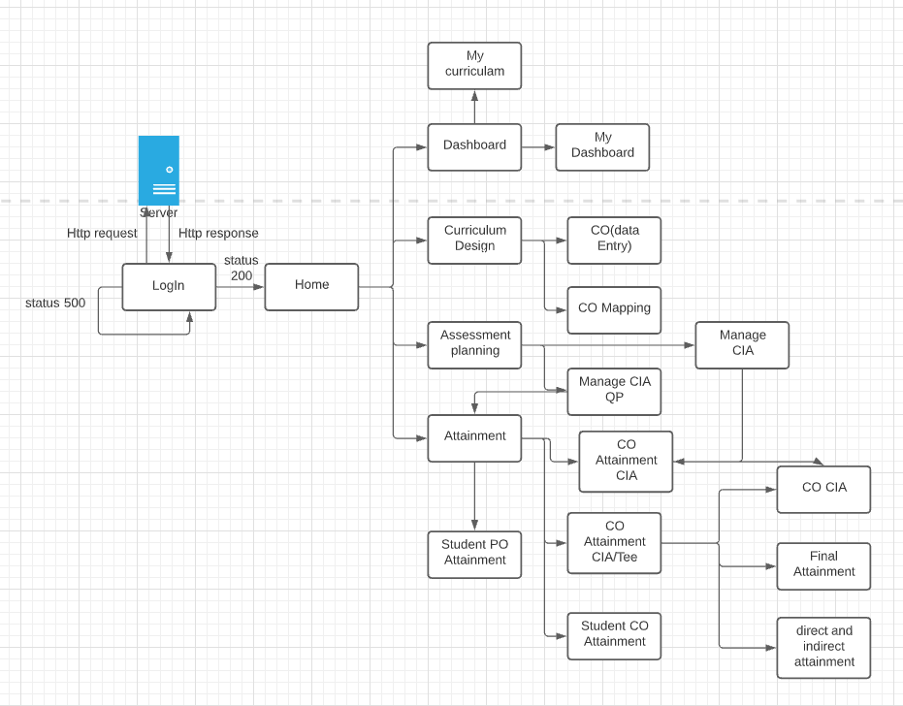

Figure 1: Work Flow

# Facilities required for proposed work

System Requirement:-

ˆ Windows 10 or Ubuntu 18.04 ˆ 12GB RAM

ˆ 512 GB Hard Disk ˆ Intel dual core i5

ˆ Latest Browser (Chrome/Firefox/Safari) ˆ Text Editor (VS Code/Sublime)

Technology Used:-

ˆ MEAN (M: Mongodb/MySql database, E: ExpressJS, A: AngularJS 8, N: NodeJS) ˆ GIT (for version control)

# References/Bibliography

1. https://docs.angularjs.org/guide/introduction. [Accessed 26 9 2021].
2. https://code.visualstudio.com/. [Accessed 26 9 2021].
3. [http://www.mongodb.org.](http://www.mongodb.org/) [Accessed 26 9 2021].
4. https://expressjs.com. [Accessed 26 9 2021].
5. https://nodejs.org/api/child_process.html. [Accessed 26 9 2021].
6. h[ttps://www.git-scm.com/docs/git-co](http://www.git-scm.com/docs/git-commit)mmit. [Accessed 26 9 2021].